SLMC – Database Application

User Manual

V1.0

Getting Started

1. Login Window

* The first window that appears after installation.
* Here’s where you’ll get to login to your account to continue with data entry into the database.

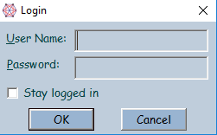

1. Click OK.
2. Select whether you want to save your account credentials.
3. Enter your password.
4. Enter your username.
5. Dashboard

* The main window that appears after login.
* Here you’ll get to see a basic overview of the database.
* This is the main menu to all other functions of the application.

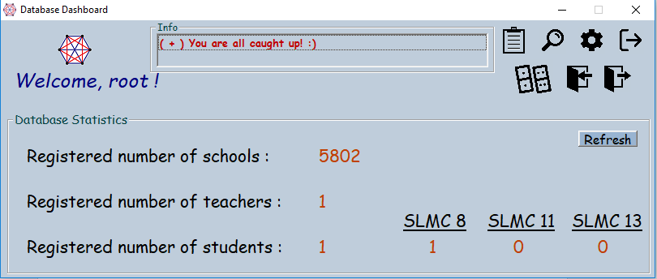

Log out of account

**Left Click** to enter **normal applications.**

**Right Click** to enter **basic applications.**

Refresh database stats.

1. Normal Applications

* This window will allow you to enter applications into the database.
* The interface is divided into sections based on the different details in the application.
* It’s possible to resize this window for convenience.

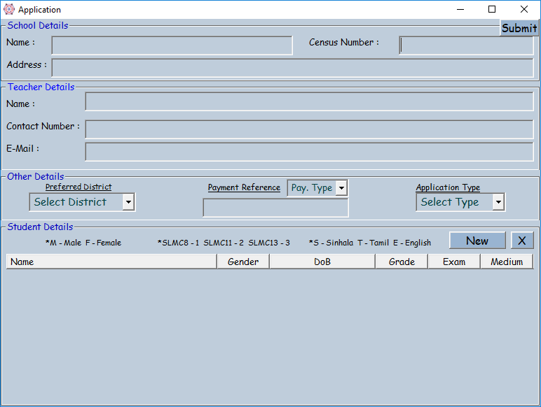

**\*Make sure none of the data you type, contains quotations! - “ ”**

Procedure

1. Enter Census number of School (5 digits) and press enter.
2. The program will check with the database and the name of the school will appear.

*The application will not be submitted if it does not find a match for the school in the database.*

1. Enter the address of the school.
2. Enter teacher details.
3. Select the preferred district of taking the exam.
4. Select the payment method.
5. For bank payment, no reference number is needed but for eZCash, the reference number should be typed in.
6. Select application type.

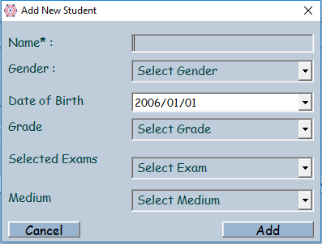

1. To enter details of a new student, click on ‘New’ in the student details section.
2. In the new window, add details of a student and click on add.
3. You can delete students in the list by selecting them from the list and clicking “X”.
4. Clicking on Submit at the top corner will submit the application.
5. The program will return the **number of the application** which should be written on the hardcopy.

*The TAB key can be used to cycle between text boxes and selections during the data entry procedure.*

1. Basic Applications
   * This window will allow you to enter applications in a basic level into the database.
   * Only 4 fields of data are required to be entered.
   * This window cannot be resized.

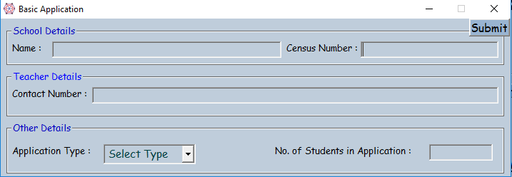

1. Duplicate Applications

* + This window will appear whenever you submit an application from a school which already has applications submitted to the database.
  + Here, you’ll be able to view the details of applications from the same school which are already in the database and decide whether or not to submit the current application.
  + This window cannot be resized.

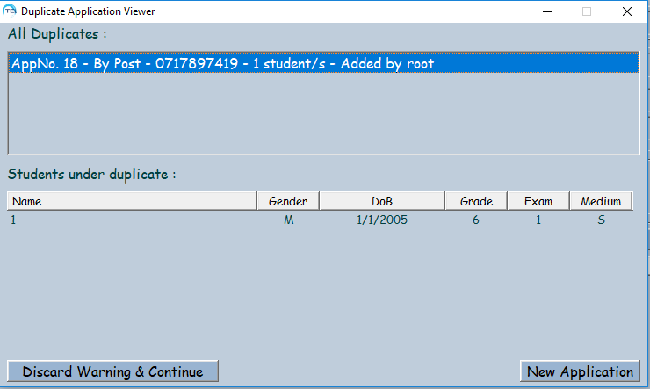

If the current application is already there, start typing a new application.

Continue adding the current application into the database.

Advanced Functions



**Upload – Used to upload school and regional data into the database. Highly technical, not for the normal user.**

**Settings - can be used for more technical things, like location of the database & login credential removal.**